## Table - Search Engine

Write a function that **searches** in a **table** by given input.

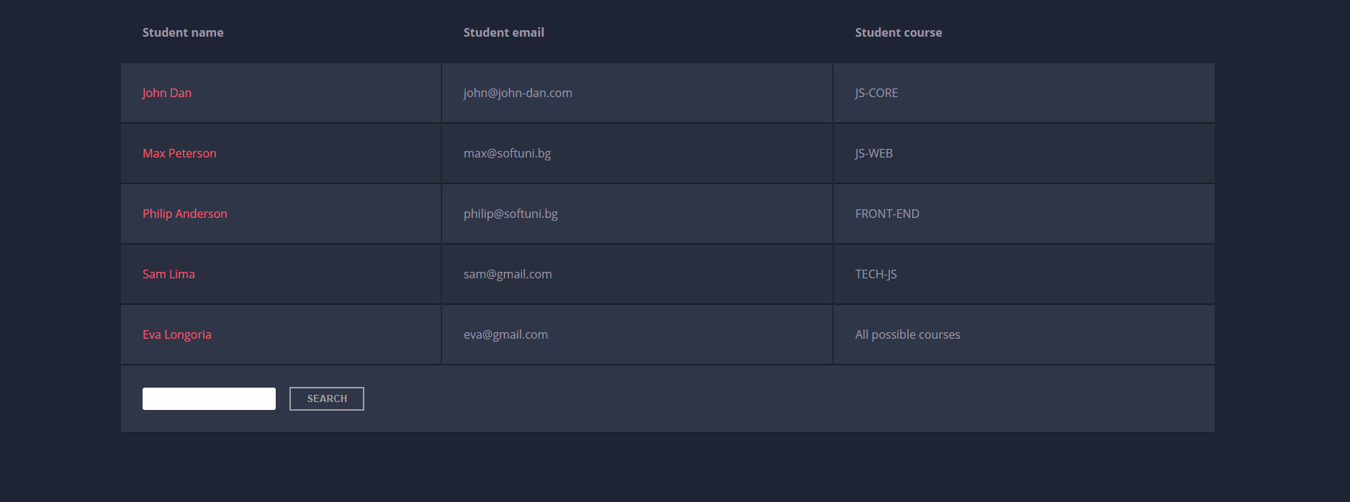

When the "**Search**" **button** is **clicked**, go through all cells in the table except for the first row (Student name, Student email, and Student course) and check if the given input has a match (check for both **full words** and **single letters**).

If any of the rows contain the submitted string, add a class select to that row. Note that more than one row may contain the given string.

Оtherwise, if there is no match, **nothing should happen**.

**Note:** After every search ("Search" button is clicked), **clear** **the input field** and **remove** **all already selected classes** (if any) from the previous search, for the **new search** to contain only the **new result**.

For instance, if we try to find **eva:**

The result should be:

